# How to Fix Tags in Acrobat File without Mouse

## Go to Tags Panel

Alt-V, S, N, G

## Open/Collapse Items in Tag Tree

Once in the tag tree,

* Use the right arrow button to expand items
* Use the left arrow button to collapse

## Create New/Edit Existing Tags

1. Go into the tag tree.
2. Press the Menu/Application button. It’s usually between the Control and Windows button toward the right side on the bottom row. It looks like this:  
     
   This will bring up this dialogue:  
   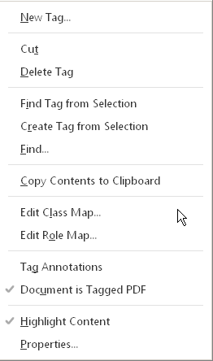
3. Create a new tag—Type N.
4. Changing the properties of an existing tag—Type P

## Cutting and Pasting Tags

Use Menu/Application button on keyboard to bring up dialogues on left.

|  |  |
| --- | --- |
| cid:image004.png@01D20835.41489390  cid:image005.png@01D20835.41489390 | You can use this technique to move tags. |